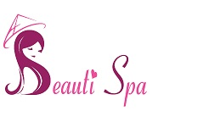
Beauti Spa
47 High Street – Barkingside – IG6 2AD
Tel: 02086171414
Email: info@beautispa.co.uk
Parental Consent Form
The information being collected on this form will only be used for the purpose of parental consent for any client who is under the age of 16 and wishing to have the beauty treatment, specified below, at Beauti Spa. We request that you complete the details below and return to us prior to treatment, this form will then be stored along with the young person’s record card. If the client is under the age of 16 will also be required to have a parent or guardian present throughout the treatment.
Name of young person: ________________________________________ Treatment: ______________________________________
Please fill out your details below:
Name: _____________________________________
Relationship to young person: _______________________________
Address: ______________________________________________________ ____________________________________ Postcode: _________________
Contact Number: _________________________________
I _________________________________ am happy to give my consent for _______________________________ to have the specified treatment/s. I have checked the record card details and can confirm they are correct. Both myself and the young person fully understand what the treatment involves and have read and understood any pretreatment and aftercare advice.
Signed (parent/guardian): _________________________________________ Date: ________________________
Signed (young person): ____________________________________________ Date: ________________________
Signed (therapist): ________________________________________________ Date: ________________________

